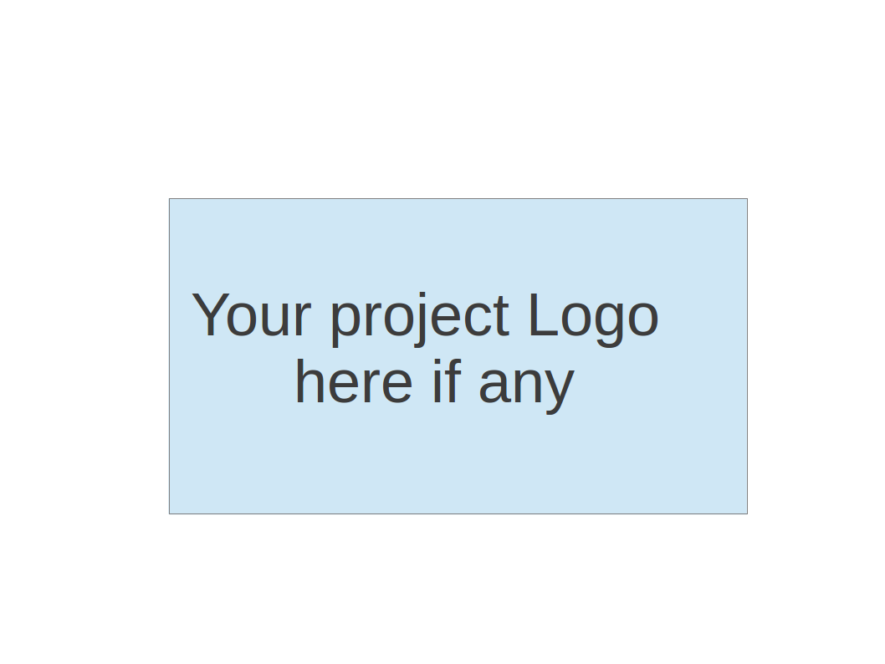
CS673 Software Engineering
Team 3 - Movie Data Visualization Platform
Userstories

[TEAM3-26] User Story 3_6 - Refresh movie data in real-time from external sources Created: 10/Oct/24 Updated: 12/Oct/24
Status: | Icebox
Project: | CS673 Team 3
Components: | None
Affects versions: | None
Fix versions: | None

Type: | Feature | Priority: | Medium
Reporter: | Hengyi Song | Assignee: | Hengyi Song
Resolution: | Unresolved | Votes: | 0
Labels: | None
Σ Remaining Estimate: | Not Specified | Remaining Estimate: | Not Specified
Σ Time Spent: | Not Specified | Time Spent: | Not Specified
Σ Original Estimate: | Not Specified | Original estimate: | Not Specified

Sub-tasks:
  Key | Summary | Type | Status | Assignee
  TEAM3-32 | External Data Source Integration for ... | Subtask | To Do | Xuansheng Xia
  TEAM3-33 | Real-Time Data Fetching and Synchroni... | Subtask | To Do | Xuansheng Xia
  TEAM3-34 | Automated Visualizations Update | Subtask | To Do | Xuansheng Xia
  TEAM3-35 | Testing and Validation of Real-Time D... | Subtask | To Do | Xuansheng Xia
Rank: | 0|i0004v:
Story point estimate: | 5

Description

As a system administrator, I want the platform to refresh movie data in real-time from external sources,
So that the visualizations always reflect the latest information without manual updates.

Acceptance Test 1:
Given: The platform is connected to external movie data sources,
When: New data becomes available,
Then: The platform should automatically update the movie information in real-time.

Acceptance Test 2:
Given: The platform is displaying movie data visualizations,
When: The data is refreshed in real-time,
Then: The visualizations should update accordingly to reflect the latest movie information.

[TEAM3-25] User Story 3_5 - Create an account and save my dashboard preferences Created: 10/Oct/24 Updated: 12/Oct/24
Status: | Icebox
Project: | CS673 Team 3
Components: | None
Affects versions: | None
Fix versions: | None

Type: | Feature | Priority: | Medium
Reporter: | Hengyi Song | Assignee: | Hengyi Song
Resolution: | Unresolved | Votes: | 0
Labels: | None
Σ Remaining Estimate: | Not Specified | Remaining Estimate: | Not Specified
Σ Time Spent: | Not Specified | Time Spent: | Not Specified
Σ Original Estimate: | Not Specified | Original estimate: | Not Specified

Sub-tasks:
  Key | Summary | Type | Status | Assignee
  TEAM3-28 | User Registration and Account Creation | Subtask | To Do | Xuansheng Xia
  TEAM3-29 | Dashboard Customization and Preferenc... | Subtask | To Do | Xuansheng Xia
  TEAM3-30 | User Login and Preference Retrieval | Subtask | To Do | Xuansheng Xia
  TEAM3-31 | Testing and Validation of Account and... | Subtask | To Do | Xuansheng Xia
Rank: | 0|i0004n:
Story point estimate: | 5

Description

As a frequent user of the platform, I want to create an account and save my dashboard preferences, so that I can return to the platform with my customized settings intact.

Acceptance Test 1:
Given: A dataset of movie reviews,
When: The user requests a word cloud,
Then: The system should generate a word cloud that highlights the most frequently mentioned terms.

Acceptance Test 2:
Given: A dataset of movie reviews,
When: The user requests sentiment analysis,
Then: The system should categorize the reviews into positive, neutral, and negative sentiments.

[TEAM3-24] user story 3-8 Top Movies by Genre Created: 10/Oct/24 Updated: 16/Oct/24
Status: | Icebox
Project: | CS673 Team 3
Components: | None
Affects versions: | None
Fix versions: | None

Type: | Feature | Priority: | Medium
Reporter: | Ziliang Ren | Assignee: | Ziliang Ren
Resolution: | Unresolved | Votes: | 0
Labels: | None
Remaining Estimate: | Not Specified
Time Spent: | Not Specified
Original estimate: | Not Specified

Rank: | 0|i00051:

Description

As a user, I want to see a list of top-rated movies for each genre, so that I can explore the best movies in categories that interest me.
Acceptance Test 1:
Given: A dataset of movies with ratings and genres,
When: The user selects a specific genre,
Then: The system should display a ranked list of the top-rated movies in that genre.
Acceptance Test 2:
Given: A dataset of movies with ratings,
When: The user specifies the number of movies they want to see (e.g., top 10),
Then: The system should adjust the list to display the top-rated movies up to the specified number.

[TEAM3-23] user story 3-7 - Movie Ratings Visualization Created: 10/Oct/24 Updated: 16/Oct/24
Status: | Icebox
Project: | CS673 Team 3
Components: | None
Affects versions: | None
Fix versions: | None

Type: | Feature | Priority: | Medium
Reporter: | Ziliang Ren | Assignee: | Ziliang Ren
Resolution: | Unresolved | Votes: | 0
Labels: | None
Remaining Estimate: | Not Specified
Time Spent: | Not Specified
Original estimate: | Not Specified

Rank: | 0|i0004z:

Description

As a user, I want to visualize the distribution of movie ratings, so that I can understand the overall rating trends for different movies.
Acceptance Test 1:
Given: A dataset of movie ratings,
When: The user requests a ratings distribution visualization,
Then: The system should generate a chart that shows the frequency of each rating across the dataset.
Acceptance Test 2:
Given: A dataset with both high and low ratings,
When: The user filters the data by a specific range (e.g., 4-5 stars),
Then: The system should update the chart to only show the ratings within the specified range.

[TEAM3-6] User Story 3_4 - Apply Custom Filters to Visualized Data Created: 10/Oct/24 Updated: 10/Oct/24
Status: | Icebox
Project: | CS673 Team 3
Components: | None
Affects versions: | None
Fix versions: | None

Type: | Feature | Priority: | Medium
Reporter: | Xuansheng Xia | Assignee: | Xuansheng Xia
Resolution: | Unresolved | Votes: | 0
Labels: | None
Σ Remaining Estimate: | Not Specified | Remaining Estimate: | Not Specified
Σ Time Spent: | Not Specified | Time Spent: | Not Specified
Σ Original Estimate: | Not Specified | Original estimate: | Not Specified

Sub-tasks:
  Key | Summary | Type | Status | Assignee
  TEAM3-11 | Implement filter by rating | Subtask | To Do | Xuansheng Xia
  TEAM3-12 | Implement filter by genre | Subtask | To Do | Xuansheng Xia
  TEAM3-13 | Implement filter by language | Subtask | To Do | Xuansheng Xia
  TEAM3-14 | Test filter functionalities | Subtask | To Do | Xuansheng Xia
Rank: | 0|i0000e:i
Story point estimate: | 5

Description

As a user, I want to apply custom filters (e.g., rating, genre, language) to the visualized data, so that I can focus on specific movie categories or attributes relevant to my research.
Acceptance Test 1:
Given: A dataset of movie reviews,
When: The user applies a filter by genre,
Then: The system should display only reviews that belong to the selected genre.
Acceptance Test 2:
Given: A dataset of movie reviews,
When: The user applies a filter by rating,
Then: The system should display only reviews with the selected rating.

[TEAM3-5] User Story 3_3 - Generate Word Cloud and Perform Sentiment Analysis Created: 10/Oct/24 Updated: 10/Oct/24
Status: | Icebox
Project: | CS673 Team 3
Components: | None
Affects versions: | None
Fix versions: | None

Type: | Feature | Priority: | Medium
Reporter: | Xuansheng Xia | Assignee: | Xuansheng Xia
Resolution: | Unresolved | Votes: | 0
Labels: | None
Σ Remaining Estimate: | Not Specified | Remaining Estimate: | Not Specified
Σ Time Spent: | Not Specified | Time Spent: | Not Specified
Σ Original Estimate: | Not Specified | Original estimate: | Not Specified

Sub-tasks:
  Key | Summary | Type | Status | Assignee
  TEAM3-7 | Collect movie review dataset | Subtask | To Do | Xuansheng Xia
  TEAM3-8 | Clean and preprocess the dataset | Subtask | To Do | Xuansheng Xia
  TEAM3-9 | Perform sentiment analysis | Subtask | To Do | Xuansheng Xia
  TEAM3-10 | Generate word cloud | Subtask | To Do | Xuansheng Xia
Rank: | 0|i0000e:
Story point estimate: | 8

Description

As a user, I want to generate a word cloud from movie reviews and perform sentiment analysis, so that I can understand the general tone of user feedback and the most frequently mentioned terms in reviews.
Acceptance Test 1:
Given: A dataset of movie reviews,
When: The user requests a word cloud,
Then: The system should generate a word cloud that highlights the most frequently mentioned terms.
Acceptance Test 2:
Given: A dataset of movie reviews,
When: The user requests sentiment analysis,
Then: The system should categorize the reviews into positive, neutral, and negative sentiments.

[TEAM3-2] User Story 3_2 - Analyze Language Diversity in Movies Created: 03/Oct/24 Updated: 11/Oct/24
Status: | Icebox
Project: | CS673 Team 3
Components: | None
Affects versions: | None
Fix versions: | None

Type: | Feature | Priority: | Medium
Reporter: | Xiao Juan Li | Assignee: | Xiao Juan Li
Resolution: | Unresolved | Votes: | 0
Labels: | None
Σ Remaining Estimate: | Not Specified | Remaining Estimate: | Not Specified
Σ Time Spent: | Not Specified | Time Spent: | Not Specified
Σ Original Estimate: | Not Specified | Original estimate: | Not Specified

Sub-tasks:
  Key | Summary | Type | Status | Assignee
  TEAM3-19 | Extract and clean movie language data | Subtask | To Do | Xuansheng Xia
  TEAM3-20 | Analyze language distribution | Subtask | To Do | Xuansheng Xia
  TEAM3-21 | Create a bar chart visualization | Subtask | To Do | Xuansheng Xia
  TEAM3-22 | Test the implementation | Subtask | To Do | Xuansheng Xia
Rank: | 0|i0000d:
Story point estimate: | 5

Description

As a user, I want to analyze the diversity of languages used in movies so that I can study trends in language representation in the film industry.
- Acceptance Test 1:

Given the menu “Language Diversity” is available.

When I click on this menu.

Then I should see a bar chart visualizing the number of movies produced in various languages.
- Acceptance Test 2:

Given the bar chart of language diversity is displayed.

When I hover over a specific language bar.

Then I should see the exact number of movies produced in that language as a tooltip or label.

[TEAM3-1] User Story 3_1- Explore Movie Runtimes Created: 03/Oct/24 Updated: 11/Oct/24
Status: | Icebox
Project: | CS673 Team 3
Components: | None
Affects versions: | None
Fix versions: | None

Type: | Feature | Priority: | Medium
Reporter: | Xiao Juan Li | Assignee: | Xiao Juan Li
Resolution: | Unresolved | Votes: | 0
Labels: | None
Σ Remaining Estimate: | Not Specified | Remaining Estimate: | Not Specified
Σ Time Spent: | Not Specified | Time Spent: | Not Specified
Σ Original Estimate: | Not Specified | Original estimate: | Not Specified

Sub-tasks:
  Key | Summary | Type | Status | Assignee
  TEAM3-15 | Extract and clean movie runtime data | Subtask | To Do | Xuansheng Xia
  TEAM3-16 | Analyze runtime distribution | Subtask | To Do | Xuansheng Xia
  TEAM3-17 | Create a histogram visualization | Subtask | To Do | Xuansheng Xia
  TEAM3-18 | Test the implementation | Subtask | To Do | Xuansheng Xia
Rank: | 0|i0000b:
Story point estimate: | 5

Description

As a user, I want to explore the distribution of movie runtimes so that I can study trends in movie length across the industry.
- Acceptance Test 1:
Given the menu “Movie Runtimes” is available.
When I click on this menu.
Then I should see a histogram where the x-axis displays specific runtime ranges (e.g., 0-60 minutes, 61-120 minutes) and the y-axis shows the number of movies in each runtime range.
- Acceptance Test 2:
Given the histogram of movie runtimes is displayed.
When I hover over a specific runtime range (e.g., 61-120 minutes).
Then I should see the exact number of movies in that range as a tooltip or label.

Updated in iter 2: completed User Stories(Xiao Juan Li) total points 36
User Story 3-19: Top Movie Production Companies Bar Chart
User Story:
As a user, I want to explore the top movie production companies by productions so that I can identify industry leaders in film production.
Acceptance Test 1:
- Given the menu “Top Movie Production Companies” is available,
- When I click on this menu,
- Then I should see a bar chart displaying the top production companies, with the x-axis showing their productions and each company listed along the y-axis.
Acceptance Test 2:
- Given the bar chart of top movie production companies is displayed,
- When I select a different top range from the dropdown menu (e.g., Top 5, Top 10),
- Then the chart should update to display the selected number of companies with their respective scores.
Acceptance Test 3:
- Given the chart of top movie production companies is displayed,
- When I hover over a specific bar (representing a production company),
- Then I should see a tooltip with the exact name of the company and its score value.

Story point estimate: 8

User Story 3-20: Top Movie Production Companies Bubble Chart

User Story:
As a user, I want to compare movies by their ratings and awards so that I can understand the relationship between a movie’s rating and its recognition in terms of awards.
Acceptance Test 1:
- Given the menu “Ratings VS Awards” is available,
- When I click on this menu,
- Then I should see a bubble chart where the x-axis displays movie ratings, the y-axis shows the number of awards, and each bubble represents a movie with size indicating the movie’s gross earnings and color distinguishing different award types (e.g., Oscar, BAFTA).
Acceptance Test 2:
- Given the bubble chart of movie ratings vs. awards is displayed,
- When I hover over a specific bubble,
- Then I should see a tooltip with detailed information about the movie, including the title, rating, number of awards, and gross earnings.
Acceptance Test 3:
- Given the bubble chart of movie ratings vs. awards is displayed,
- When I toggle between different award types (e.g., Oscar, BAFTA) using a filter or legend,
- Then the chart should update to display bubbles only for movies that received the selected award type(s).

Story point estimate: 7

User Story 3-21: Movie Ratings Nested Pie Chart

User Story:
As a user, I want to view the distribution of movie ratings across different genres so that I can analyze how ratings vary by genre.
Acceptance Test 1:
- Given the menu “Ratings Distribution” is available,
- When I click on this menu,
- Then I should see a nested pie chart (or sunburst chart) that displays the distribution of ratings. The inner circle should represent different genres (e.g., Drama, Adventure, Thriller), and the outer rings should represent specific rating categories (e.g., 8.0, 8.1, 8.2).
Acceptance Test 2:
- Given the ratings distribution chart is displayed,
- When I hover over a specific rating section within a genre,
- Then I should see a tooltip with detailed information, including the rating score, the number of movies with that rating, and the percentage of the total.
Acceptance Test 3:
- Given the ratings distribution chart is displayed,
- When I toggle between different rating ranges (e.g., 8.0–8.5, 8.6–9.0) or genres,
- Then the chart should update to focus on the selected range or genre, helping me to refine my analysis of movie ratings distribution.

Story point estimate: 6

User Story 3-22: Movie production by country Funnel Chart

User Story:
As a user, I want to view a visual representation of movie production by country so that I can easily identify the leading movie-producing countries.
Acceptance Test 1:
- Given the “Movie Production by Country” menu is available,
- When I click on this menu,
- Then I should see a funnel chart displaying the top countries by movie production, with each country represented in descending order based on the number of movies produced.
Acceptance Test 2:
- Given the funnel chart of movie production by country is displayed,
- When I hover over a specific country section,
- Then I should see a tooltip showing the country's name and the exact number of movies produced by that country.

Story point estimate: 5

User Story 3-23: Movie releases across year intervals

User Story:
As a user, I want to explore the distribution of movie releases across different year intervals so that I can identify trends and patterns in movie production over time.
Acceptance Test 1:
- Given the “Distributions of Movie Releases by Year Intervals” menu is available,
- When I click on this menu,
- Then I should see a circular chart that displays the distribution of movie releases grouped by specified year intervals (e.g., [1921, 1926], [1961, 1966]).
Acceptance Test 2:
- Given the circular chart of movie release intervals is displayed,
- When I hover over a specific segment representing a year interval,
- Then I should see a tooltip showing the exact year interval and the number of movie releases within that interval.
Acceptance Test 3:
- Given the circular chart is displayed,
- When I select a different range filter (e.g., every 5 years, 10 years),
- Then the chart should update to display the distribution of movie releases according to the selected range, allowing me to analyze movie production trends over different intervals.

Story point estimate: 5

First Generated at Fri Oct 18 05:00:32 UTC 2024 by Xiao Juan Li using Jira 1001.0.0-SNAPSHOT#100270-rev:582039e53e997ecddb7d2905e1827db609c6b94f.

